SQL Assignment – 1

Products Table :

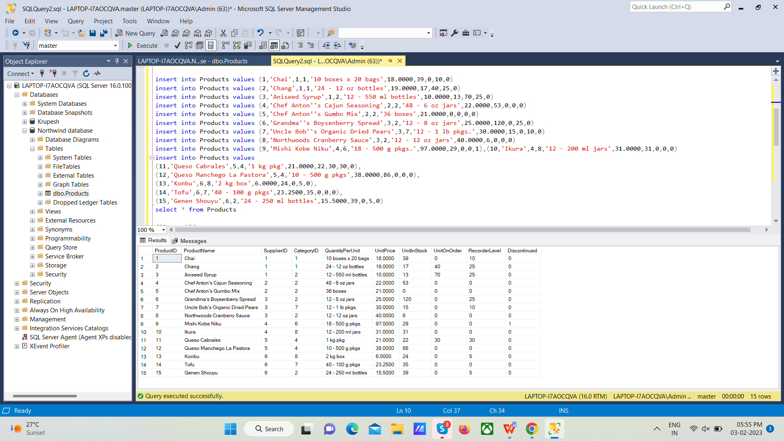

**Query for creating table :**

create table Products(

ProductID int not null PRIMARY KEY,

ProductName varchar(40),

SupplierID int not null,

CategoryID int not null,

QuantityPerUnit varchar(20) not null,

UnitPrice decimal (10,4),

UnitInStock smallint not null,

UnitOnOrder smallint not null,

RecorderLevel smallint not null,

Discontinued bit

)

**Query for Inserting data into table :**

insert into Products values (1,'Chai',1,1,'10 boxes x 20 bags',18.0000,39,0,10,0)

insert into Products values (2,'Chang',1,1,'24 - 12 oz bottles',19.0000,17,40,25,0)

insert into Products values (3,'Aniseed Syrup',1,2,'12 - 550 ml bottles',10.0000,13,70,25,0)

insert into Products values (4,'Chef Anton''s Cajun Seasoning',2,2,'48 - 6 oz jars',22.0000,53,0,0,0)

insert into Products values (5,'Chef Anton''s Gumbo Mix',2,2,'36 boxes',21.0000,0,0,0,0)

insert into Products values (6,'Grandma''s Boysenberry Spread',3,2,'12 - 8 oz jars',25.0000,120,0,25,0)

insert into Products values (7,'Uncle Bob''s Organic Dried Pears',3,7,'12 - 1 lb pkgs.',30.0000,15,0,10,0)

insert into Products values (8,'Northwoods Cranberry Sauce',3,2,'12 - 12 oz jars',40.0000,6,0,0,0)

insert into Products values (9,'Mishi Kobe Niku',4,6,'18 - 500 g pkgs.',97.0000,29,0,0,1),(10,'Ikura',4,8,'12 - 200 ml jars',31.0000,31,0,0,0)

insert into Products values

(11,'Queso Cabrales',5,4,'1 kg pkg',21.0000,22,30,30,0),

(12,'Queso Manchego La Pastora',5,4,'10 - 500 g pkgs',38.0000,86,0,0,0),

(13,'Konbu',6,8,'2 kg box',6.0000,24,0,5,0),

(14,'Tofu',6,7,'40 - 100 g pkgs',23.2500,35,0,0,0),

(15,'Genen Shouyu',6,2,'24 - 250 ml bottles',15.5000,39,0,5,0)

**Q – 1 : Write a query to get a Product list (id, name, unit price) where current products cost less than $20.**

/*Query 1*/

select ProductID, ProductName, UnitPrice from Products where (UnitPrice<20 and Discontinued=0)

**Output :**

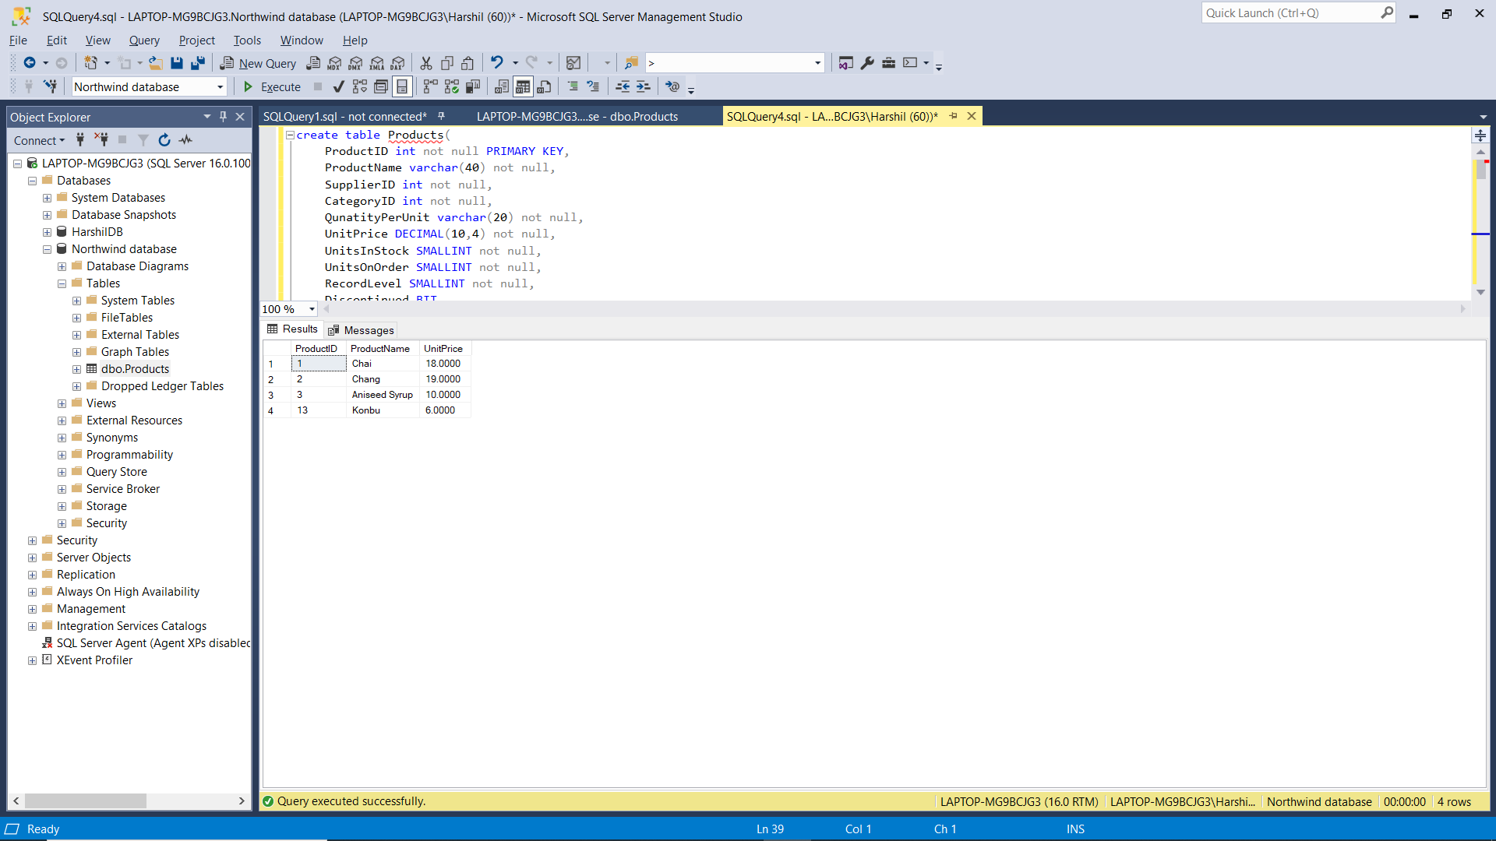

**Q – 2 : Write a query to get Product list (id, name, unit price) where products cost between $15 and $25**

/* Query 2*/

select ProductID, ProductName, UnitPrice from Products where (UnitPrice between 15 and 25)

**Output :**

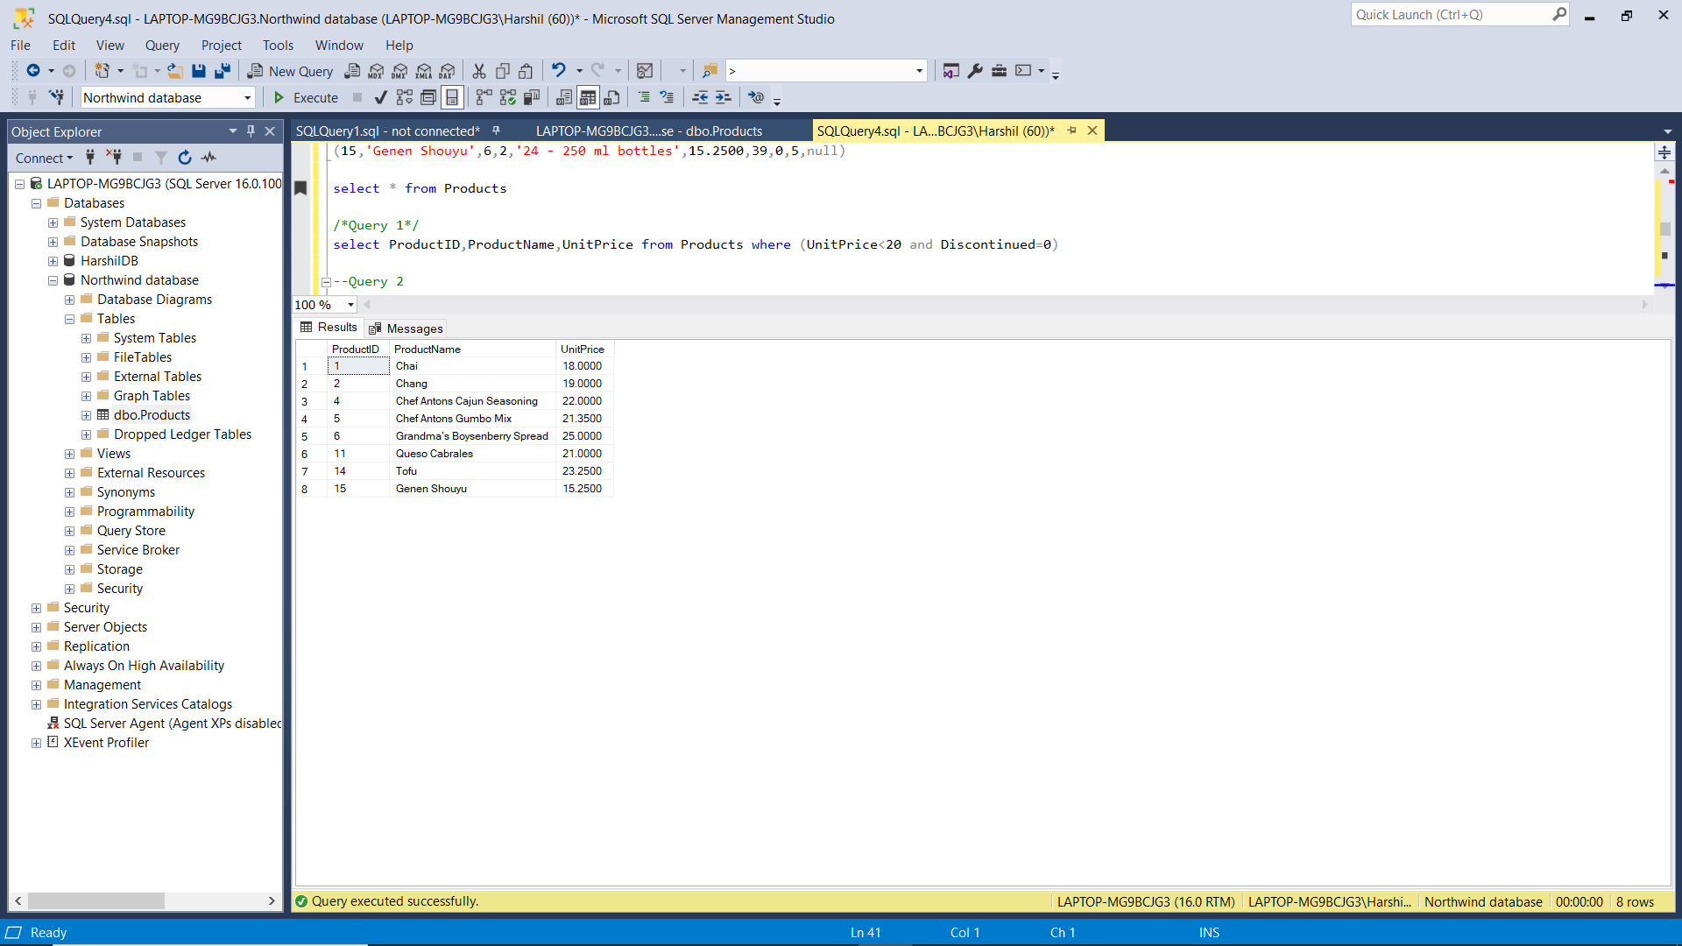

**Q – 3 : Write a query to get Product list (name, unit price) of above average price.**

/* Query 3*/

select ProductName, UnitPrice from Products where ((Unitprice) > (select AVG(Unitprice) from Products))

**Output :**

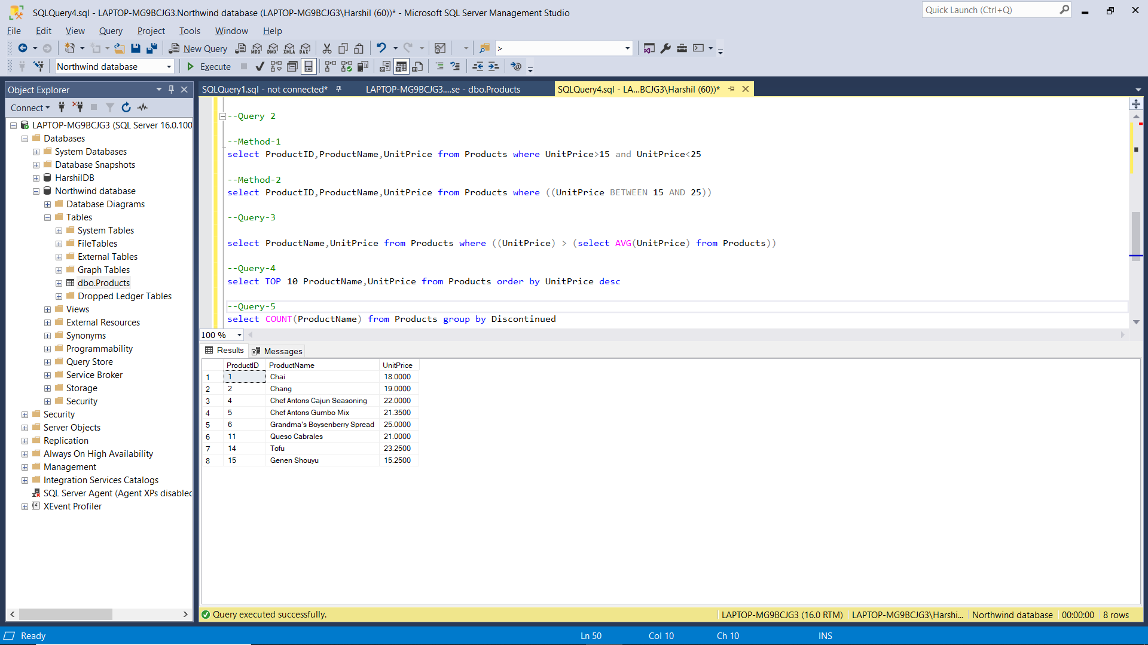

**Q – 4 : Write a query to get Product list (name, unit price) of ten most expensive products**

/* Query 4*/

select TOP 10 ProductName, UnitPrice from Products order by UnitPrice desc

**Output :**

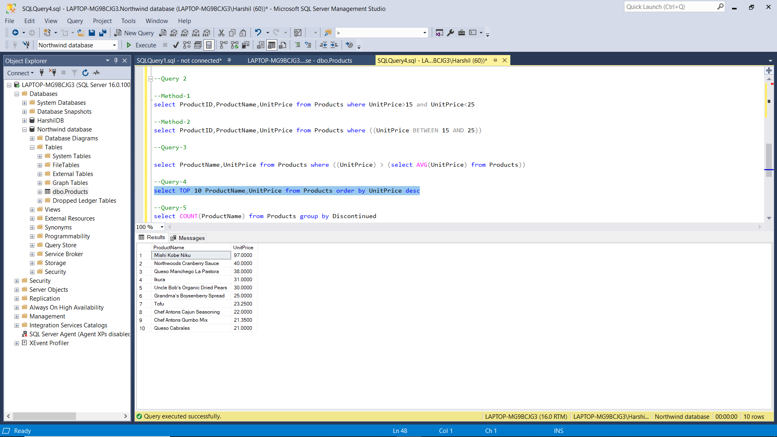

**Q – 5 : Write a query to count current and discontinued products**

/* Query 5*/

select COUNT(Productname) from Products group by Discontinued

**Output :**

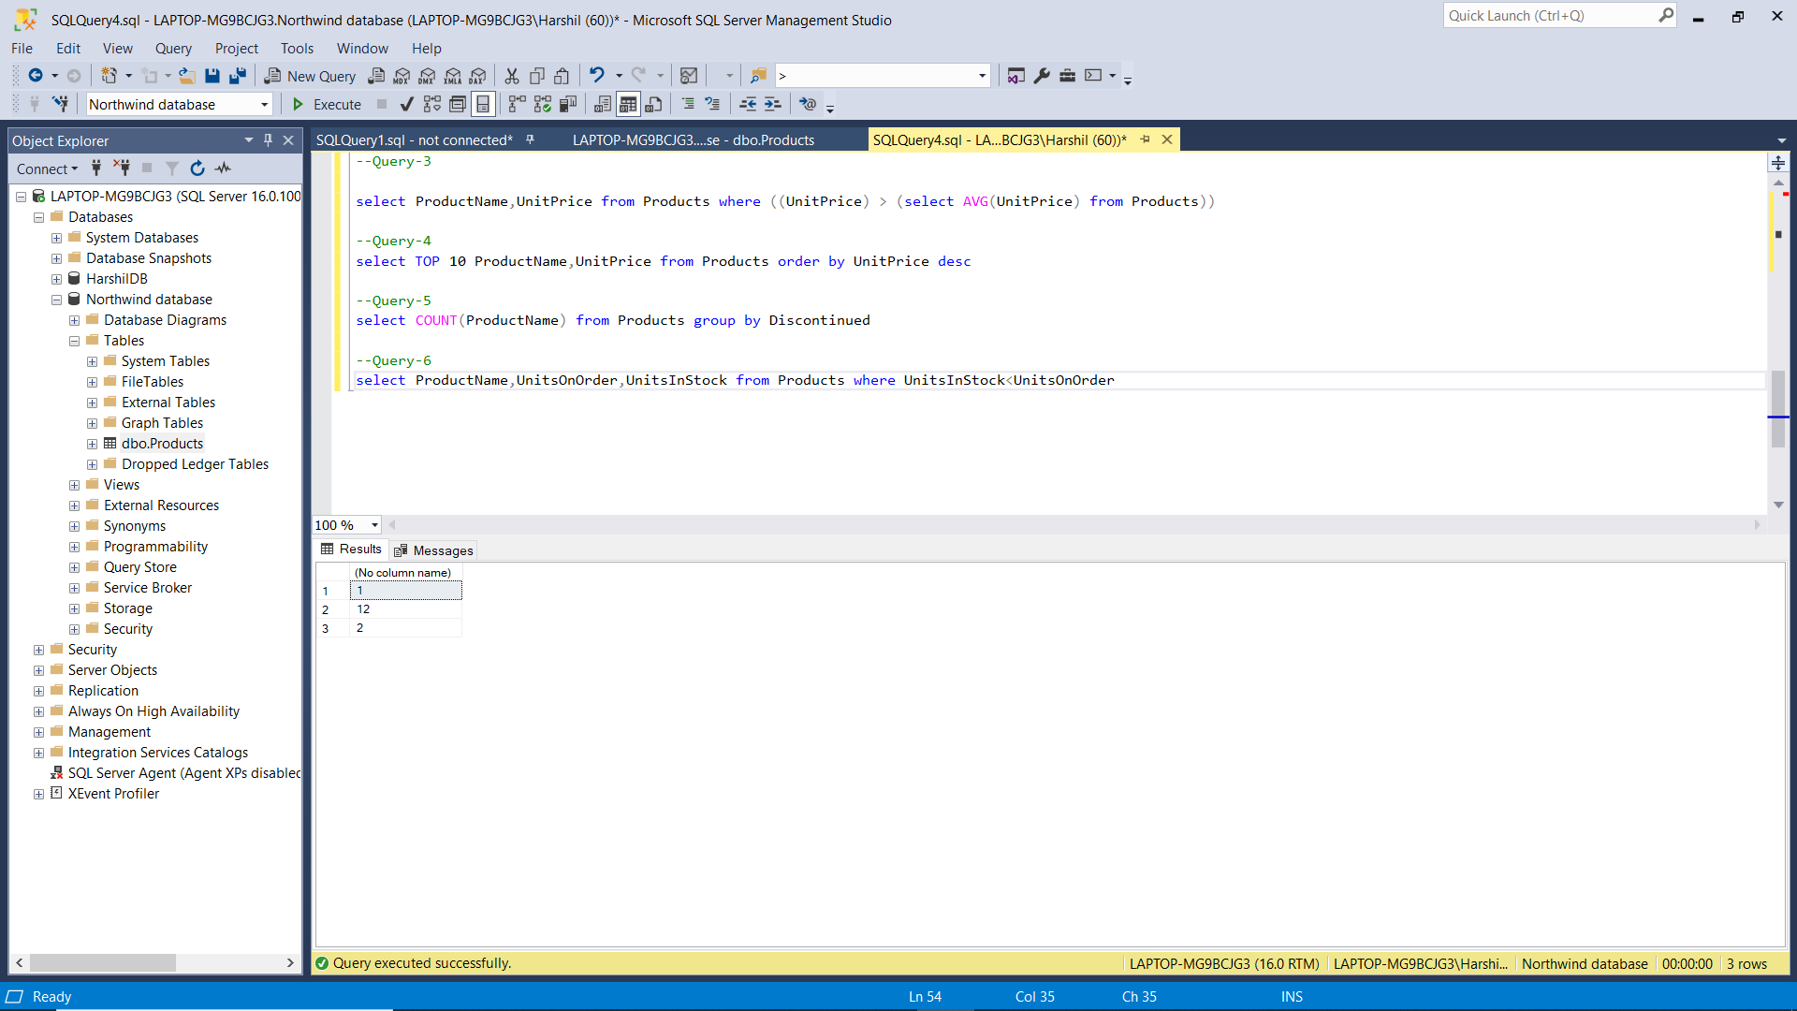

**Q – 6 : Write a query to get Product list (name, units on order , units in stock) of stock is less than the quantity on order**

/* Query 6*/

select Productname, UnitOnOrder, UnitInStock from Products where UnitInStock < UnitOnOrder

**Output :**

